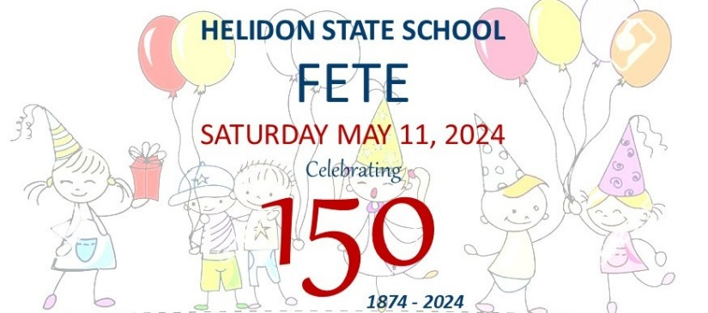

2024 is a very special year for Helidon State School as we celebrate our 150th Anniversary.
The Helidon State School P&C is pleased to invite you to sponsor our P&C through one of our exciting sponsorship opportunities.
Your sponsorship will assist in helping us create an exciting and memorable school and community event in May 2024.
Funds raised by our P&C support improving learning and wellbeing outcomes at our wonderful school.
The impact for your business will be increased exposure and community goodwill across the Lockyer Valley and beyond.

Our objectives are to support the Helidon State School and the community in ways that include:
ü Weekly bi-weekly Breakfast Club and supplies for lunches—healthy food options for students.
ü Subsidise annual school-based swimming lesson program.
ü Supporting chaplaincy and student wellbeing initiatives.
ü Subsidise the cost to parents for a variety of events such as camps, excursions and graduation events.
ü Organise events such as Mother’s Day afternoon tea and Barn Dance BBQ.

Sponsorship Packages
Cash and In-Kind OR Raffle Prizes
PLATINUM Sponsor | FIREWORKS Sponsor | MAJOR Raffle Prize
$3,000+ $3,000 $2,000+
Branding on official fete signage | Banner on main event stage
Priority public acknowledgements at the Fete | Banner on Warrego Hwy fence to Dec 2024 (sponsor provides)
Priority branding in all school and fete publications | Media Promotions – social media, newspaper and radio
Free market stall space (4m x 4m) | 2 x complimentary rides passes
GOLD Sponsor | SILVER Sponsor SILVER Raffle Prize
$1,500+ $750+ $1,000+
Banner on school fence (sponsor provides) | Prominent branding in all school and fete publications
Public acknowledgements at the Fete | Banner on Warrego Hwy fence for Gold (sponsor provides)
Discounted 4m x 4m market stall space (free for Gold) | Media Promotions – social media, newspaper (radio for Gold)
BRONZE Sponsor | BRONZE Raffle Prize | SMALL Raffle Prize
$250+ $250+ up to $250
Banner on school fence to 30th June 2024 (sponsor provides) | Small/Medium branding in school and fete publications
Public acknowledgements at the Fete for raffle sponsors | Promotion in school social media
Discounted 4m x 4m market stall space

For the full list of Sponsorship Inclusions go to https://helidonss.eq.edu.au/our-community/150-th-anniversary-in-2024 (click on Expression of Interest link)

For more information
Mark Robertson, Helidon State School Principal: 07 4612 9222
Sandra Freiberg, Helidon State School P&C President: 0444 514 772
Email: PandC@helidonss.eq.edu.au
Your Sponsorship in Action
Select from the options listed or discuss your other ideas with us. GST is not applicable.
Cash or In-Kind
PLATINUM Sponsor $3,000+  ☐ Cash to use where needed  ☐ Ride – The Swinger $4,180 |  | FIREWORKS Sponsor $3,000  ☐ Help us to light up the early evening sky.
GOLD Sponsor $1,500+  ☐ Cash to use where needed  ☐ Ride –Jumping Castle $1,650  ☐ Ride – Tea Cups $1,980  ☐ Kids animal petting zoo $1,300  ☐ First Aid provider | SILVER Sponsor $750+  ☐ Cash to use where needed  ☐ Amusement – Dunk Tank $990  ☐ Generator hire (rides) $1,100  ☐ Hire – toilets, flood lights, generator  ☐ Bands – band fee and PA hire |  | BRONZE Sponsor $250+  ☐ Cash to use where needed  ☐ Printing – posters, signs & car stickers  ☐ Food ingredients and drinks  ☐ Hire – tables and chairs
Raffle Prizes
MAJOR Prize $2,000+
☐ New car

☐ New Boat/Jet Ski | ☐ Motor Bike |  | ☐ Cruise or Holiday
☐ Ride-on Mower | ☐ Cash |  | ☐ Another product or service
SILVER Prize  $1,000 - $1,999 | BRONZE Prize  $250 - $999 |  | SMALL Prize  Up to $250

Sponsorship Expression of Interest
Complete this form and return it to Helidon State School P&C Association, or contact the school’s Principal (email below or call 07 4612 9222):
Email: PandC@helidonss.eq.edu.au
Post of Hand Deliver: 16 School St, Helidon Qld 4344
Business / Organisation Name:  Click or tap here to enter text. | Contact Name:  Click or tap here to enter text.
Mailing Address:  Click or tap here to enter text. | Email address:  Click or tap here to enter text.
Phone Number:  Click or tap here to enter text. | Company/Organisation Website:  Click or tap here to enter text.
Choose Cash or In-Kind sponsorship categories (click box):
☐ Platinum ☐ Fireworks ☐ Gold ☐ Silver ☐ Bronze Market stall space: ☐ Yes ☐ No
Cash sponsorship value *: $ Click or tap here to enter text.
In-kind sponsorship value (RRP) *: $ Click or tap here to enter text.
In-kind sponsorship details: Click or tap here to enter text.
Total value of sponsorship (cash value + in-kind value) *: $ Click or tap here to enter text.
Choose Raffle Prize sponsorship category (click box)
☐ Major ☐ Silver ☐ Bronze ☐ Small Market stall space: ☐ Yes ☐ No
Prize value (RRP) *: $ Click or tap here to enter text.
Prize details (including T&Cs): Click or tap here to enter text.
* GST not applicable to sponsorships

